Amoeba_Team @IPG

Recherche axes

Free-living amoebae (FLA) are ubiquitous protists (unicellular eukaryotes) that can be found in soils and freshwater, feeding on bacteria. Amongst the most common genera of FLA, some can be pathogenic causing encephalitis (*Acanthamoeba* spp., *Balamuthia mandrillaris*, *Sappinia pedata* and *Naegleria fowleri*). *Acanthamoeba spp*. can also cause keratitis. The genera *Acanthamoeba* and *Vermamoeba* also have medical importance as hosts, vehicles, and training grounds for bacteria.

In France, the first fatal case of infection with *N. fowleri* was reported in a geothermal bath in Guadeloupe (French West Indies) in 2008.

Since then, we developed at the Institut Pasteur de Guadeloupe, 3 major research axes: figure

* Axis 1: *Naegleria fowleri* biology and pathogenesis.
* Axis 2: diversity and distribution of FLA.
* Axis 3: Services.

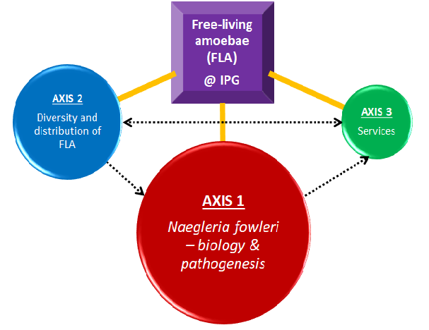

Axis 1 - Naegleria fowleri biology and pathogenesis

Members of the *Naegleria* genus belong to the major eukaryotic lineage Heterolobosea. Over 50 recognized species detected, *N. fowleri* (also called brain-eating amoeba)is the only one being pathogenic to humans, causing a rare but fulminant primary amoebic meningoencephalitis (PAM).

PAM affects mainly healthy children or young adults (Sarink et al. 2021). The infection occurs when contaminated water enters the nose; *N. fowleri* (specially trophozoites) follows the olfactory nerve to the brain through the cribriform plate. There, it induces phagocytosis of brain material, provoking tissue damage and hemorrhagic necrosis causing a fatal brain infection. The disease progresses rapidly leading to death within 7-12 days (Moseman 2020). Combined with its low incidence (Trabelsi et al. 2012; Siddiqui et al. 2016), early diagnosis is difficult (the PAM symptoms closely resembled bacterial meningitis (Jahangeer et al. 2020); the link with Naegleria is usually made post-mortem by microscopic examination of the cerebral spinal fluid or by quantitative PCR.

In recent years, an increased number of PAM cases have been reported worldwide, in particularly in temperate regions and developing countries; this is probably due to global warming, global overpopulation, increased industrial activities (Kemble et al., 2012; Siddiqui et al., 2016; Maciver et al., 2020). Despite successful treatment options with miltefosine and other antimicrobial medication (Debnath 2021), the mortality rate is still significant, suggesting the need to find effective therapies (Khan et al., 2021).

To develop improved diagnostic tools and/or provide an early and effective treatment against *N. fowleri* infection, it to improve the knowledge on the biology and the pathogenesis of this amoeba.

*Naegleria fowleri* is a remarkable microorganism:

(i) it exists in 3 distinct forms (Figure xxxx),

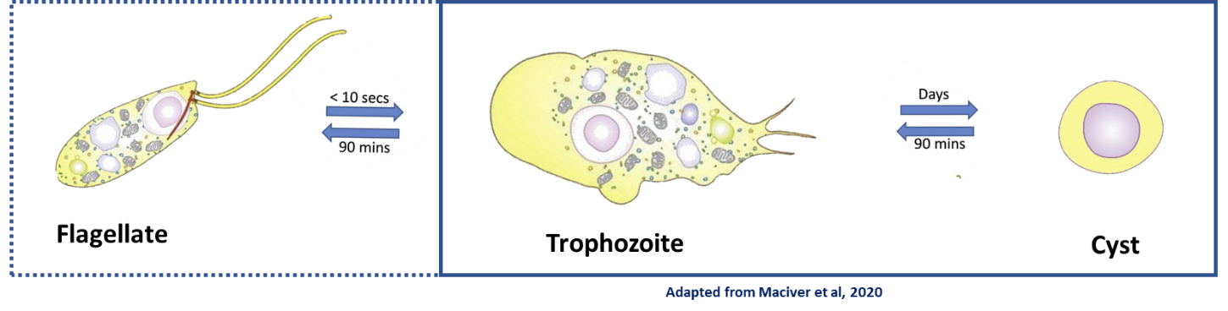

(ii) can survive in different ecosystems (host, water, soil, air) (Figure xxxxx),

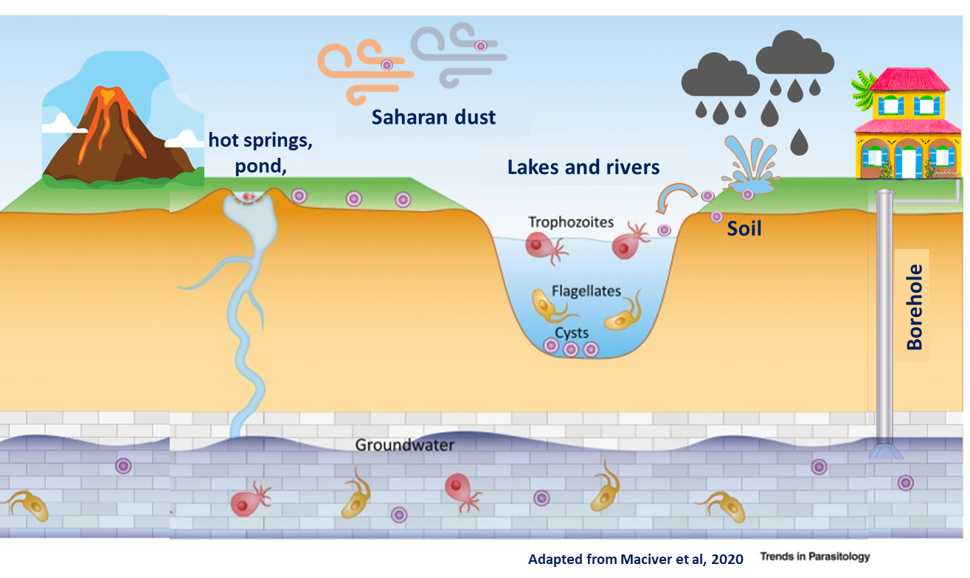

(iii) can use different sources of nutrients in vivo and in vitro, (iv) exists under different genotypes in the world, (v) can induce asymptomatic infections in humans, and (vi) can harbor pathogenic microorganisms, in particular viruses and bacteria. The degree of virulence of *N. fowleri* trophozoites in culture has been shown to vary depending on the strain and the culture conditions.

These observations raise many questions (Figure xxxxx).

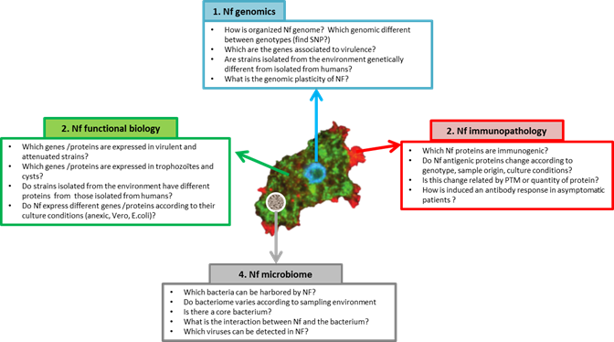

At the Institut Pasteur de Guadeloupe, we aim to answer to some of these questions, using genomics, transcriptomics, metagenomics, and bioinformatics.

Axis 2 - FLA diversity and distribution:

Free-living amoebae (FLA) can be found all around the word in natural or man-made environments including wastewater treatment plants, drinking water networks, tap water, hospital water networks, hot springs, swimming pools, rivers, deserts, wet soils, in sediments and in soil from agricultural and mining sites. Although the incidence of human infections by pathogenic FLA low (*Acanthamoeba* spp., *Balamuthia mandrillaris*, *Sappinia pedata* and *Naegleria fowleri*) is generally, new cases are being constantly reported worldwide [23,24]

3-Services

This axis is not directly associated with a fundamental research project, but with support to the human health service for the detection and identification of amoebae in Guadeloupe (meningitis, keratitis, or others). In fact, I am convinced that this type of support could lead to interesting research projects in collaboration with the ARS, the CHU and others. For example, the agreements signed with ARS and ANSES made it possible to finance certain research activities at IPG and recently resulted in the funding of the GwadAmib'O project in 2020 (IPG / ARS / Office de l'Eau ).

Lab members

Aurélie DELUMEAU, M2 student

Vincent GUERLAIS, Bioinformatician

Isabel MARCELINO, PhD, HDR

After completing undergraduate studies in Biochemistry at the University de Faro (Alrgave, Portugal), I started my PhD in Chemical Engineering the Animal Cell technology Lab (ITQB/IBET, Oeiras, Portugal). During my PhD I developed a poress at semi-industrial scale for the production, purification and tsoirage of an inactivated gaianst Hearwtater, a tcik-borne disease caused by the bligate ontracellular bacteria HElichia ruminantium. As I wanted to know more about the mecha isms underlying the bacterium virulence and itsinterection with it endlthelial host cells, I moved to the Mass >Specteromtry lab a(ITBQB, Oeiras, Portugal), as a post-doc and PI of a research project, where I focused on understanding the complex process of host-pathgen interaction using proteoùics tools. Afterwards, I moved to CIRAD, in Guadeloupe (French West Indies), where a set-up a 2D-DIGE proteomic platfrm and conitune my studies on E,urimeintium -host cells interaction and E.rumeintium atjogeniss (in portuclar Post-translational modifitons). Then, I intregrated the Instsitut Pasteur of Guadeloupe to work on free-living amoeba and in partcilair on the brain-eating amoeba Nagelria fowleri biology and pathogenis, using genomics an dtranscriptomics to idenifty virulence associated factors. At IPG, I belong to the LEMIC and I lead the IPG Amoeba Team.

<https://orcid.org/0000-0001-5454-8811>.

Youri VINGATARAMIN, PhD student

Publications & Book chapters

Free-living amoebae

1. Reynaud Y, Ducat C, Talarmin A, **Marcelino I.** (2020) Cartography of Free-Living Amoebae in Soil in Guadeloupe (French West Indies) Using DNA Metabarcoding. Pathogens, doi: 10.3390/pathogens9060440.
2. Moussa M, **Marcelino I**, Richard V, Guerlotté J, Talarmin A. (2020) An Optimized Most Probable Number (MPN) Method to Assess the Number of Thermophilic Free-Living Amoebae (FLA) in Water Samples. Pathogens, doi:10.3390/pathogens9050409.

*E.ruminantium* pathogenesis

1. Pinarello V, Bencurova E, **Marcelino I**, Gros O, Puech C, Bhide M, Vachiery N, Meyer DF. (2021) *Ehrlichia ruminantium* uses its transmembrane protein Ape to adhere to host bovine aortic endothelial cells. bioRxiv, doi:10.1101/2021.06.15.447525.

1. **Marcelino I**, Holzmuller P, Coelho A, Mazzucchelli G, Fernandez B, Vachiéry N. (2021) Revisiting *Ehrlichia ruminantium* Replication Cycle Using Proteomics: The Host and the Bacterium Perspectives. Microorganisms, doi: 10.3390/microorganisms9061144.
2. **Marcelino I**, Colomé-Calls N, Holzmuller P, Lisacek F, Reynaud Y, Canals F, Vachiéry N. (2019) Sweet and Sour *Ehrlichia*: Glycoproteomics and Phosphoproteomics Reveal New Players in *Ehrlichia ruminantium* Physiology and Pathogenesis. Front Microbiol, doi: 10.3389/fmicb.2019.00450.
3. **Marcelino I,** Holzmuller P, Stachurski F, Rodrigues V, Vachiéry N. (2016) *Ehrlichia ruminantium*: The Causal Agent of Heartwater. In: Thomas S. (eds) Rickettsiales. Springer, Cham. <https://doi.org/10.1007/978-3-319-46859-4_13>
4. **Marcelino I**, Ventosa M, Pires E, Müller M, Lisacek F, Lefrançois T, Vachiery N, Coelho AV. (2015) Comparative Proteomic Profiling of Ehrlichia ruminantium Pathogenic Strain and Its High-Passaged Attenuated Strain Reveals Virulence and Attenuation-Associated Proteins. PLoS One, doi: 10.1371/journal.pone.0145328.
5. Moumène A, **Marcelino I**, Ventosa M, Gros O, Lefrançois T, Vachiéry N, Meyer DF, Coelho AV. (2015) Proteomic profiling of the outer membrane fraction of the obligate intracellular bacterial pathogen Ehrlichia ruminantium. PLoS One, doi: 10.1371/journal.pone.0116758.
6. Pruneau L, Moumène A, Meyer DF, **Marcelino I**, Lefrançois T, Vachiéry N. (2014) Understanding Anaplasmataceae pathogenesis using "Omics" approaches. Front Cell Infect Microbiol, doi: 10.3389/fcimb.2014.00086.
7. Vachiéry N, **Marcelino I**, Martinez D, Lefrançois T. (2014) Manual of Security Sensitive Microbes and Toxins. Chapter 65 - Ehrlichia ruminantium. In book: Manual of Security Sensitive Microbes and ToxinsChapter: *Ehlichia ruminantium*. Publisher: Taylor & Francis Group, LLC, Editors: Dongyou Liu, DOI: 10.1201/b16752-72
8. **Marcelino I**, Ventosa M, Pruneau L, Pires E, Meyer DF, de Almeida AM, Mari B, Lefrançois T, Coelho AV, Vachiéry N. (2013) Omics approaches to study the Rickettsia *Ehrlichia ruminantium*: towards improved knowledge on Heartwater disease. In: de Almeida A. et al. (eds) Farm animal proteomics 2013. Wageningen Academic Publishers, Wageningen. Doi: 10.3920/978-90-8686-776-9_30.
9. Ventosa M, **Marcelino I,** Coelho AV, Horlacher O, Lisacek F, Vachiéry N, Lefrançois T (2013) Automatic prediction of PTMs in *Ehrlichia ruminantium* – creating new datasets for Quickmod analyses. In: de Almeida A. et al. (eds) Farm animal proteomics 2013. Wageningen Academic Publishers, Wageningen. Doi: 10.3920/978-90-8686-776-9_20.
10. Pires E, **Marcelino I**, Vachiéry N, Lefrançois T, Mazzuchelli G, de Pauw E, Coelho AV. (2013) Changes on bovine aorta endothelial cells (BAE) proteome upon infection with the rickettsia *Ehrlichia ruminantium*. In: de Almeida A. et al. (eds) Farm animal proteomics 2013. Wageningen Academic Publishers, Wageningen. Doi: 10.3920/978-90-8686-776-9_33
11. **Marcelino I**, de Almeida AM, Ventosa M, Pruneau L, Meyer DF, Martinez D, Lefrançois T, Vachiéry N, Coelho AV. (2012) Tick-borne diseases in cattle: applications of proteomics to develop new generation vaccines. J Proteomics, doi: 10.1016/j.jprot.2012.03.026.
12. **Marcelino I**, de Almeida AM, Brito C, Meyer DF, Barreto M, Sheikboudou C, Franco CF, Martinez D, Lefrançois T, Vachiéry N, Carrondo MJ, Coelho AV, Alves PM. (2012) Proteomic analyses of *Ehrlichia ruminantium* highlight differential expression of MAP1-family proteins. Vet Microbiol, doi: 10.1016/j.vetmic.2011.11.022.
13. Pruneau L, Emboulé L, Gely P, **Marcelino I**, Mari B, Pinarello V, Sheikboudou C, Martinez D, Daigle F, Lefrançois T, Meyer DF, Vachiery N. (2012) Global gene expression profiling of *Ehrlichia ruminantium* at different stages of development. FEMS Immunol Med Microbiol, doi: 10.1111/j.1574-695X.2011.00901.x.

Inactivated vaccine production

1. **Marcelino I,** Chavez A, Gharbi M, Farber M, Holzmuller P, Martinez D, Vachiéry N. Protozoal and Rickettsial Vaccines. In book: Veterinary Vaccines: Principles and Applications, John Wiley & Sons, 2021. Doi: 10.1002/9781119506287.ch7
2. **Marcelino I**, Lefrançois T, Martinez D, Giraud-Girard K, Aprelon R, Mandonnet N, Gaucheron J, Bertrand F, Vachiéry N. (2015) A user-friendly and scalable process to prepare a ready-to-use inactivated vaccine: the example of heartwater in ruminants under tropical conditions. Vaccine, doi: 10.1016/j.vaccine.2014.11.
3. Vachiéry N, **Marcelino I**, Martinez D, Lefrançois T. (2013) Opportunities in diagnostic and vaccine approaches to mitigate potential heartwater spreading and impact on the American mainland. Dev Biol (Basel), doi: 10.1159/000190050**.**
4. Vachiéry N, Meyer D, **Marcelino I**, Alves PM, Raliniaina M, Stachurski F, Adakal H, Sheikboudou C, Aprelon R, Pinarello V, Lefrançois, Dominique Martinez. (2010). Vaccinal approach using inactivated vaccine against heartwater and Ehrlichia ruminantium genetic diversity. Advances in Animal Biosciences, doi: 10.1017/S2040470010000178.
5. Adakal H, Stachurski F, Konkobo M, Zoungrana S, Meyer DF, Pinarello V, Aprelon R, **Marcelino I**, Alves PM, Martinez D, Lefrancois T, Vachiéry N. (2010). Efficiency of inactivated vaccines against heartwater in Burkina Faso: impact of *Ehrlichia ruminantium* genetic diversity. Vaccine, doi: 10.1016/j.vaccine.2010.04.087.
6. **Marcelino I**, Sousa MFQ, Peixoto C, Amaral AI, Vachiery N, Lefrançois T, Martinez D, Carrondo MJTC, Alves PM. (2010) Development of a Vaccine Candidate Against Heartwater. In: Noll T. (eds) Cells and Culture. ESACT Proceedings, vol 4. Springer, Dordrecht. Doi: 10.1007/978-90-481-3419-9_122
7. Faburay B, Geysen D, Ceesay A, **Marcelino I**, Alves PM, Taoufik A, Postigo M, Bell-Sakyi L, Jongejan F. (2007) Immunisation of sheep against heartwater in The Gambia using inactivated and attenuated *Ehrlichia ruminantium* vaccines. Vaccine, doi: 10.1016/j.vaccine.2007.09.002.
8. **Marcelino I**, Vachiéry N, Amaral AI, Roldão A, Lefrançois T, Carrondo MJ, Alves PM, Martinez D. (2007) Effect of the purification process and the storage conditions on the efficacy of an inactivated vaccine against heartwater. Vaccine, doi: 10.1016/j.vaccine.2007.04.055.
9. Peixoto C, Marcelino I, Amaral AI, Carrondo MJT, Alves PM. (2007) Purification by membrane technology of an intracellular *Ehrlichia ruminantium* candidate vaccine against heartwater. Process Biochemistry, doi: 10.1016/j.procbio.2007.04.012
10. **Marcelino I**, Sousa MFQ, Amaral AI, Peixoto C, Verissimo C, Cunha A, Carrondo MJT, Alves PM. (2007) Process Development for a Veterinary Vaccine Against Heartwater Using Stirred Tanks. In: Smith R. (eds) Cell Technology for Cell Products. Springer, Dordrecht. Doi: 10.1007/978-1-4020-5476-1_116
11. **Marcelino I**, Sousa MFQ, Veríssimo C, Cunha AE, Carrondo MJ, Alves PM (2006). Process development for the mass production of Ehrlichia ruminantium. Vaccine, doi: 10.1016/j.vaccine.2005.08.109.
12. **Marcelino I**, Veríssimo C, Sousa MF, Carrondo MJ, Alves PM. (2005) Characterization of Ehrlichia ruminantium replication and release kinetics in endothelial cell cultures. Vet Microbiol, doi: 10.1016/j.vetmic.2005.07.012. PMID: 16139967.
13. Peixoto CC, **Marcelino I**, Vachiéry N, Bensaid A, Martinez D, Carrondo MJ, Alves PM. (2005) Quantification of *Ehrlichia ruminantium* by real time PCR. Vet Microbiol, doi: 10.1016/j.vetmic.2005.02.001.
14. Moreira JL, Miranda PM, **Marcelino I**, Alves PM, Carrondo MJT. (2003) Culture Methods for Mass Production of Ruminant Endothelial Cells. Fermentation Biotechnology, doi:10.1021/bk-2003-0862.ch008

Others research topics:

1. Matias AA, Serra AT, Silva AC, Perdigão R, Ferreira TB, **Marcelino I**, Silva S, Coelho AV, Alves PM, Duarte CM. (2010) Portuguese winemaking residues as a potential source of natural anti-adenoviral agents. Int J Food Sci Nutr, doi: 10.3109/09637480903430990.
2. Carvalhal AV, **Marcelino I**, Carrondo MJ. (2003) Metabolic changes during cell growth inhibition by p27 overexpression. Appl Microbiol Biotechnol, doi: 10.1007/s00253-003-1385-5.
3. Carvalhal AV, Santos SS, Coroadinha A, **Marcelino I**, Carrondo MJT. (2003) Cell Growth Arrest by Nucleotides as a Tool for Improved Production of Biopharmaceuticals. In: Yagasaki K., Miura Y., Hatori M., Nomura Y. (eds) Animal Cell Technology: Basic & Applied Aspects. Animal Cell Technology: Basic & Applied Aspects, vol 13. Springer, Dordrecht. Doi: 10.1007/978-94-017-0726-8_14.

Projects:

|  |  |  |  |  |
| --- | --- | --- | --- | --- |
| **Périodea** | **Projet** | **Type de financement** | **Activité** | **Budget** |
| 2001-2004 | PROCORDEL - « Vaccin Cowdriose » | Union Européenne (8 ACP TPS 040) | Recherche (étudiante en thèse) | - |
| 2004-2008 | Integrated Consortium on Ticks and Tick-borne diseases – ICTTD3 | Union Européenne (Coordination Action No. 510561). | Partenaire du projet | - |
| 2005-2009 | EPIGENEVAC | Union Européenne  (N°FP6 -003713) | Recherche, Gestion scientifique et rapports budgétaires | 117 200 € (4 ans, IBET)) |
| **2011-2014** | **ER_TRANSPORT** | **Portugal (PTDC/CVT/114118/2009)** | **Gestion financière et scientifique** | **155 947 € (3 ans) \*** |
| 2011-2014 | COST Action « Farm Animal proteomics » | Union Européenne(FA1002) | Partenaire du projet | - |
| **2014-2015** | **REcProtER** | **Programme Stefanik (projet bilatéral France- Slovaquie)** | **Rédaction du projet; coordination scientifique** | **Approx. 4500 € pour 2 ans (voyages + mission)** |
| 2014-2016 | EPIGENESIS | Union Européenne (FP7-REGPOT-2012-2013-1) | Mise e place d’un nouveau laboratoire de protéomique; coordination scientifique (volet « protéomique ») | 300 k€ pour la plateforme 2D DiGE |
| 2016-2020 | MALIN - Maladies infectieuses en milieu insulaire tropical (MALIN1 et 2) | Union Européenne (FEDER), Région Guadeloupe et les partenaires | Expertise scientifique (volet AMIBES) | -- |
| 2018 | Campagne GUAMAR  (Campagne prélèvements Amibes sources d’eau chaude – Guadeloupe et Martinique) | ANSES | Expertise technique et scientifique | 9 200 € |
| 2018-2019 | Campagne prélèvements Amibes (GP) | ARS | Gestion technique et scientifique | 16 800 € |
| 2020 | Campagne prélèvements Amibes (GP) | ARS | Gestion technique et scientifique | 12 000 € |
| **GwadAmib’O** | **ARS + Office de l’Eau** | **Gestion technique et scientifique** | **40 000 € \*** |

Collaborations:

• ARS : Didier ROUX, Léa CLAIR

• ANSES : Thierry CHESNOT

• Costa Rica : University of Costa Rica, San Pedro, Costa Rica (Lissette RETANA-MOREIRA)

• EUA : University of Georgia (Christopher RICE) ; Duke University School of Medicine (Ashley MOSEMAN); Centers for Disease Control and Prevention (Ibne KARIM)

Alumni:

1. RAGUEL Manuella. Stage de découverte à la recherche (Master 2 - Stage de 1 mois). Ecole Inter-Régionale d’Infirmiers Anesthésistes Diplômés d’État (IADE), Université des Antilles.
2. AGOT Samuel. Stage en Entreprise (4 mois). Licence professionnelle Bio-industries et Biotechnologies. Université Paris Sud.
3. DENAUT MAHDAOUI Alicemène. Stage de découverte à la recherche (Master 2 - Stage de 1 mois). Ecole Inter-Régionale d’Infirmiers Anesthésistes Diplômés d’État (IADE), Université des Antilles.
4. PLUMASSEAU Nathael. Stage de Master 1 (2 mois) - Sciences, Technologies, Santé. Université Clermont Auvergne - UFR Médecine
5. VINGATARAMIN Youri. Stage de Master 2 - Santé en milieu tropical-Guadeloupe. Université des Antilles –UFR Sciences Exactes et Naturelles. (6 mois)
6. ALLOUCH Nina. Stage de Master 2- co-encadrmetn avec Alexis DEREEPER
7. DELUMEAU Aurélie. Stage de Master 1 (co(encadrement avec Prof. Olvier Gros).
8. BARRILLIOT Julie. Stage de découverte à la recherche (Master 2 - Stage de 1 mois). Ecole Inter-Régionale d’Infirmiers Anesthésistes Diplômés d’État (IADE), Université des Antilles.
9. DELUMEAU Aurélie. Stage de Master 2 (co-encadrement avec Prof. Olvier Gros).